

**Mawlana Bhashani Science and Technology University**

Santosh, Tangail-1902.

|  |
| --- |
| **Lab Report** |

Department of Information and Communication Technology

**Report No:** 03

**Report Name:** TCP and router queues.

**Course Title:** Wireless and Mobile Communication.

**Course Code:** ICT-4201

|  |  |
| --- | --- |
| Submitted By | Submitted To |
| Name: **Amrita kamkar**  ID: **IT-14060**  Session: 2013-14  4th Year 2nd Semester  Dept. of Information & Communication Technology, MBSTU. | Nazrul Islam  Assistant Professor  Dept. of Information & Communication Technology, MBSTU. |

Submission Date: 11-09-2020

**Experiment No:**03

**Experiment Name:** TCP and Router queues

**Objectives:** This lab work is a combination of TCP and Router queues. The first one or the TCP queues is quite similar with the TCP variants work. The additional Router queue make the work different. For this lab, first need to create a network based on different nodes having two individual IP addresses. An installed TCP socket instance extended the node connection through the node 1 to node 3. Particularly, the node 1 would connect to node 2 & node 2 would connect to node 4.The queue sizes are upto 6 where their drop tails are added to the same number of nodes.Queue5 and Queue 6 are to the node 5 &6.Apart from these, the packet loss & time, plot graphs throughput & time also need to be measured.

**Theoretical explanation:** The entire lab work is based on a .cc file called queue-discs-benchmark.cc file

// This example serves as a benchmark for all the queue discs (with BQL enabled or not)

//

// Network topology

//

// 192.168.1.0 192.168.2.0

// n1 ------------------------------------ n2 ----------------------------------- n3

// point-to-point (access link) point-to-point (bottleneck link)

// 100 Mbps, 0.1 ms bandwidth [10 Mbps], delay [5 ms]

// qdiscs PfifoFast with capacity qdiscs queueDiscType in {PfifoFast, ARED, CoDel, FqCoDel, PIE} [PfifoFast]

// of 1000 packets with capacity of queueDiscSize packets [1000]

// netdevices queues with size of 100 packets netdevices queues with size of netdevicesQueueSize packets [100]

// without BQL bql BQL [false]

// *** fixed configuration ***

//

// Two TCP flows are generated: one from n1 to n3 and the other from n3 to n1.

// Additionally, n1 pings n3, so that the RTT can be measured.

//

// The output will consist of a number of ping Rtt such as:

//

// /NodeList/0/ApplicationList/2/$ns3::V4Ping/Rtt=111 ms

// /NodeList/0/ApplicationList/2/$ns3::V4Ping/Rtt=111 ms

// /NodeList/0/ApplicationList/2/$ns3::V4Ping/Rtt=110 ms

// /NodeList/0/ApplicationList/2/$ns3::V4Ping/Rtt=111 ms

// /NodeList/0/ApplicationList/2/$ns3::V4Ping/Rtt=111 ms

// /NodeList/0/ApplicationList/2/$ns3::V4Ping/Rtt=112 ms

// /NodeList/0/ApplicationList/2/$ns3::V4Ping/Rtt=111 ms

//

// The files output will consist of a trace file with bytes in queue and of a trace file for limits

// (when BQL is enabled) both for bottleneck NetDevice on n2, two files with upload and download

// goodput for flows configuration and a file with flow monitor stats.

//

// If you use an AQM as queue disc on the bottleneck net devices, you can observe that the ping Rtt

// decrease. A further decrease can be observed when you enable BQL.

**The Queue- Discs-Benchmark consisting the following Pseudo Code:**

#include "ns3/core-module.h"

#include "ns3/network-module.h"

#include "ns3/internet-module.h"

#include "ns3/point-to-point-module.h"

#include "ns3/applications-module.h"

#include "ns3/internet-apps-module.h"

#include "ns3/traffic-control-module.h"

#include "ns3/flow-monitor-module.h"

using namespace ns3;

NS_LOG_COMPONENT_DEFINE ("BenchmarkQueueDiscs");

void

LimitsTrace (Ptr<OutputStreamWrapper> stream, uint32_t oldVal, uint32_t newVal)

{

*stream->GetStream () << Simulator::Now ().GetSeconds () << " " << newVal << std::endl;

}

void

BytesInQueueTrace (Ptr<OutputStreamWrapper> stream, uint32_t oldVal, uint32_t newVal)

{

*stream->GetStream () << Simulator::Now ().GetSeconds () << " " << newVal << std::endl;

}

static void

GoodputSampling (std::string fileName, ApplicationContainer app, Ptr<OutputStreamWrapper> stream, float period)

{

Simulator::Schedule (Seconds (period), &GoodputSampling, fileName, app, stream, period);

double goodput;

uint64_t totalPackets = DynamicCast<PacketSink> (app.Get (0))->GetTotalRx ();

goodput = totalPackets * 8 / (Simulator::Now ().GetSeconds () * 1024); // Kbit/s

*stream->GetStream () << Simulator::Now ().GetSeconds () << " " << goodput << std::endl;

}

static void PingRtt (std::string context, Time rtt)

{

std::cout << context << "=" << rtt.GetMilliSeconds () << " ms" << std::endl;

}

int main (int argc, char *argv[])

{

std::string bandwidth = "10Mbps";

std::string delay = "5ms";

std::string queueDiscType = "PfifoFast";

uint32_t queueDiscSize = 1000;

uint32_t netdevicesQueueSize = 50;

bool bql = false;

std::string flowsDatarate = "20Mbps";

uint32_t flowsPacketsSize = 1000;

float startTime = 0.1f; // in s

float simDuration = 60;

float samplingPeriod = 1;

CommandLine cmd;

cmd.AddValue ("bandwidth", "Bottleneck bandwidth", bandwidth);

cmd.AddValue ("delay", "Bottleneck delay", delay);

cmd.AddValue ("queueDiscType", "Bottleneck queue disc type in {PfifoFast, ARED, CoDel, FqCoDel, PIE, prio}", queueDiscType);

cmd.AddValue ("queueDiscSize", "Bottleneck queue disc size in packets", queueDiscSize);

cmd.AddValue ("netdevicesQueueSize", "Bottleneck netdevices queue size in packets", netdevicesQueueSize);

cmd.AddValue ("bql", "Enable byte queue limits on bottleneck netdevices", bql);

cmd.AddValue ("flowsDatarate", "Upload and download flows datarate", flowsDatarate);

cmd.AddValue ("flowsPacketsSize", "Upload and download flows packets sizes", flowsPacketsSize);

cmd.AddValue ("startTime", "Simulation start time", startTime);

cmd.AddValue ("simDuration", "Simulation duration in seconds", simDuration);

cmd.AddValue ("samplingPeriod", "Goodput sampling period in seconds", samplingPeriod);

cmd.Parse (argc, argv);

float stopTime = startTime + simDuration;

// Create nodes

NodeContainer n1, n2, n3;

n1.Create (1);

n2.Create (1);

n3.Create (1);

// Create and configure access link and bottleneck link

PointToPointHelper accessLink;

accessLink.SetDeviceAttribute ("DataRate", StringValue ("100Mbps"));

accessLink.SetChannelAttribute ("Delay", StringValue ("0.1ms"));

PointToPointHelper bottleneckLink;

bottleneckLink.SetDeviceAttribute ("DataRate", StringValue (bandwidth));

bottleneckLink.SetChannelAttribute ("Delay", StringValue (delay));

InternetStackHelper stack;

stack.InstallAll ();

// Access link traffic control configuration

TrafficControlHelper tchPfifoFastAccess;

tchPfifoFastAccess.SetRootQueueDisc ("ns3::PfifoFastQueueDisc", "MaxSize", StringValue ("1000p"));

// Bottleneck link traffic control configuration

TrafficControlHelper tchBottleneck;

if (queueDiscType.compare ("PfifoFast") == 0)

{

tchBottleneck.SetRootQueueDisc ("ns3::PfifoFastQueueDisc", "MaxSize",

QueueSizeValue (QueueSize (QueueSizeUnit::PACKETS, queueDiscSize)));

}

else if (queueDiscType.compare ("ARED") == 0)

{

tchBottleneck.SetRootQueueDisc ("ns3::RedQueueDisc");

Config::SetDefault ("ns3::RedQueueDisc::ARED", BooleanValue (true));

Config::SetDefault ("ns3::RedQueueDisc::MaxSize",

QueueSizeValue (QueueSize (QueueSizeUnit::PACKETS, queueDiscSize)));

}

else if (queueDiscType.compare ("CoDel") == 0)

{

tchBottleneck.SetRootQueueDisc ("ns3::CoDelQueueDisc");

Config::SetDefault ("ns3::CoDelQueueDisc::MaxSize",

QueueSizeValue (QueueSize (QueueSizeUnit::PACKETS, queueDiscSize)));

}

else if (queueDiscType.compare ("FqCoDel") == 0)

{

tchBottleneck.SetRootQueueDisc ("ns3::FqCoDelQueueDisc");

Config::SetDefault ("ns3::FqCoDelQueueDisc::MaxSize",

QueueSizeValue (QueueSize (QueueSizeUnit::PACKETS, queueDiscSize)));

}

else if (queueDiscType.compare ("PIE") == 0)

{

tchBottleneck.SetRootQueueDisc ("ns3::PieQueueDisc");

Config::SetDefault ("ns3::PieQueueDisc::MaxSize",

QueueSizeValue (QueueSize (QueueSizeUnit::PACKETS, queueDiscSize)));

}

else if (queueDiscType.compare ("prio") == 0)

{

uint16_t handle = tchBottleneck.SetRootQueueDisc ("ns3::PrioQueueDisc", "Priomap",

StringValue ("0 1 0 1 0 1 0 1 0 1 0 1 0 1 0 1"));

TrafficControlHelper::ClassIdList cid = tchBottleneck.AddQueueDiscClasses (handle, 2, "ns3::QueueDiscClass");

tchBottleneck.AddChildQueueDisc (handle, cid[0], "ns3::FifoQueueDisc");

tchBottleneck.AddChildQueueDisc (handle, cid[1], "ns3::RedQueueDisc");

}

else

{

NS_ABORT_MSG ("--queueDiscType not valid");

}

if (bql)

{

tchBottleneck.SetQueueLimits ("ns3::DynamicQueueLimits");

}

Config::SetDefault ("ns3::QueueBase::MaxSize", StringValue ("100p"));

NetDeviceContainer devicesAccessLink = accessLink.Install (n1.Get (0), n2.Get (0));

tchPfifoFastAccess.Install (devicesAccessLink);

Ipv4AddressHelper address;

address.SetBase ("192.168.0.0", "255.255.255.0");

address.NewNetwork ();

Ipv4InterfaceContainer interfacesAccess = address.Assign (devicesAccessLink);

Config::SetDefault ("ns3::QueueBase::MaxSize", StringValue (std::to_string (netdevicesQueueSize) + "p"));

NetDeviceContainer devicesBottleneckLink = bottleneckLink.Install (n2.Get (0), n3.Get (0));

QueueDiscContainer qdiscs;

qdiscs = tchBottleneck.Install (devicesBottleneckLink);

address.NewNetwork ();

Ipv4InterfaceContainer interfacesBottleneck = address.Assign (devicesBottleneckLink);

Ptr<NetDeviceQueueInterface> interface = devicesBottleneckLink.Get (0)->GetObject<NetDeviceQueueInterface> ();

Ptr<NetDeviceQueue> queueInterface = interface->GetTxQueue (0);

Ptr<DynamicQueueLimits> queueLimits = StaticCast<DynamicQueueLimits> (queueInterface->GetQueueLimits ());

AsciiTraceHelper ascii;

if (bql)

{

queueDiscType = queueDiscType + "-bql";

Ptr<OutputStreamWrapper> streamLimits = ascii.CreateFileStream (queueDiscType + "-limits.txt");

queueLimits->TraceConnectWithoutContext ("Limit",MakeBoundCallback (&LimitsTrace, streamLimits));

}

Ptr<Queue<Packet> > queue = StaticCast<PointToPointNetDevice> (devicesBottleneckLink.Get (0))->GetQueue ();

Ptr<OutputStreamWrapper> streamBytesInQueue = ascii.CreateFileStream (queueDiscType + "-bytesInQueue.txt");

queue->TraceConnectWithoutContext ("BytesInQueue",MakeBoundCallback (&BytesInQueueTrace, streamBytesInQueue));

Ipv4InterfaceContainer n1Interface;

n1Interface.Add (interfacesAccess.Get (0));

Ipv4InterfaceContainer n3Interface;

n3Interface.Add (interfacesBottleneck.Get (1));

Ipv4GlobalRoutingHelper::PopulateRoutingTables ();

Config::SetDefault ("ns3::TcpSocket::SegmentSize", UintegerValue (flowsPacketsSize));

// Flows configuration

// Bidirectional TCP streams with ping like flent tcp_bidirectional test.

uint16_t port = 7;

ApplicationContainer uploadApp, downloadApp, sourceApps;

// Configure and install upload flow

Address addUp (InetSocketAddress (Ipv4Address::GetAny (), port));

PacketSinkHelper sinkHelperUp ("ns3::TcpSocketFactory", addUp);

sinkHelperUp.SetAttribute ("Protocol", TypeIdValue (TcpSocketFactory::GetTypeId ()));

uploadApp.Add (sinkHelperUp.Install (n3));

InetSocketAddress socketAddressUp = InetSocketAddress (n3Interface.GetAddress (0), port);

OnOffHelper onOffHelperUp ("ns3::TcpSocketFactory", Address ());

onOffHelperUp.SetAttribute ("Remote", AddressValue (socketAddressUp));

onOffHelperUp.SetAttribute ("OnTime", StringValue ("ns3::ConstantRandomVariable[Constant=1]"));

onOffHelperUp.SetAttribute ("OffTime", StringValue ("ns3::ConstantRandomVariable[Constant=0]"));

onOffHelperUp.SetAttribute ("PacketSize", UintegerValue (flowsPacketsSize));

onOffHelperUp.SetAttribute ("DataRate", StringValue (flowsDatarate));

sourceApps.Add (onOffHelperUp.Install (n1));

port = 8;

// Configure and install download flow

Address addDown (InetSocketAddress (Ipv4Address::GetAny (), port));

PacketSinkHelper sinkHelperDown ("ns3::TcpSocketFactory", addDown);

sinkHelperDown.SetAttribute ("Protocol", TypeIdValue (TcpSocketFactory::GetTypeId ()));

downloadApp.Add (sinkHelperDown.Install (n1));

InetSocketAddress socketAddressDown = InetSocketAddress (n1Interface.GetAddress (0), port);

OnOffHelper onOffHelperDown ("ns3::TcpSocketFactory", Address ());

onOffHelperDown.SetAttribute ("Remote", AddressValue (socketAddressDown));

onOffHelperDown.SetAttribute ("OnTime", StringValue ("ns3::ConstantRandomVariable[Constant=1]"));

onOffHelperDown.SetAttribute ("OffTime", StringValue ("ns3::ConstantRandomVariable[Constant=0]"));

onOffHelperDown.SetAttribute ("PacketSize", UintegerValue (flowsPacketsSize));

onOffHelperDown.SetAttribute ("DataRate", StringValue (flowsDatarate));

sourceApps.Add (onOffHelperDown.Install (n3));

// Configure and install ping

V4PingHelper ping = V4PingHelper (n3Interface.GetAddress (0));

ping.Install (n1);

Config::Connect ("/NodeList/*/ApplicationList/*/$ns3::V4Ping/Rtt", MakeCallback (&PingRtt));

uploadApp.Start (Seconds (0));

uploadApp.Stop (Seconds (stopTime));

downloadApp.Start (Seconds (0));

downloadApp.Stop (Seconds (stopTime));

sourceApps.Start (Seconds (0 + 0.1));

sourceApps.Stop (Seconds (stopTime - 0.1));

Ptr<OutputStreamWrapper> uploadGoodputStream = ascii.CreateFileStream (queueDiscType + "-upGoodput.txt");

Simulator::Schedule (Seconds (samplingPeriod), &GoodputSampling, queueDiscType + "-upGoodput.txt", uploadApp,

uploadGoodputStream, samplingPeriod);

Ptr<OutputStreamWrapper> downloadGoodputStream = ascii.CreateFileStream (queueDiscType + "-downGoodput.txt");

Simulator::Schedule (Seconds (samplingPeriod), &GoodputSampling, queueDiscType + "-downGoodput.txt", downloadApp,

downloadGoodputStream, samplingPeriod);

// Flow monitor

Ptr<FlowMonitor> flowMonitor;

FlowMonitorHelper flowHelper;

flowMonitor = flowHelper.InstallAll();

Simulator::Stop (Seconds (stopTime));

Simulator::Run ();

flowMonitor->SerializeToXmlFile(queueDiscType + "-flowMonitor.xml", true, true);

Simulator::Destroy ();

return 0;

}

**Procedures To be Followed:** The queue discs benchmark.cc file consisted the .cc extention.This file then need to be put in two different folders. First I need to go to the home page in the linux. Then ns-allinone-3.30 & ns-3.30.There would be some visible files among them I need to select the scratch file.

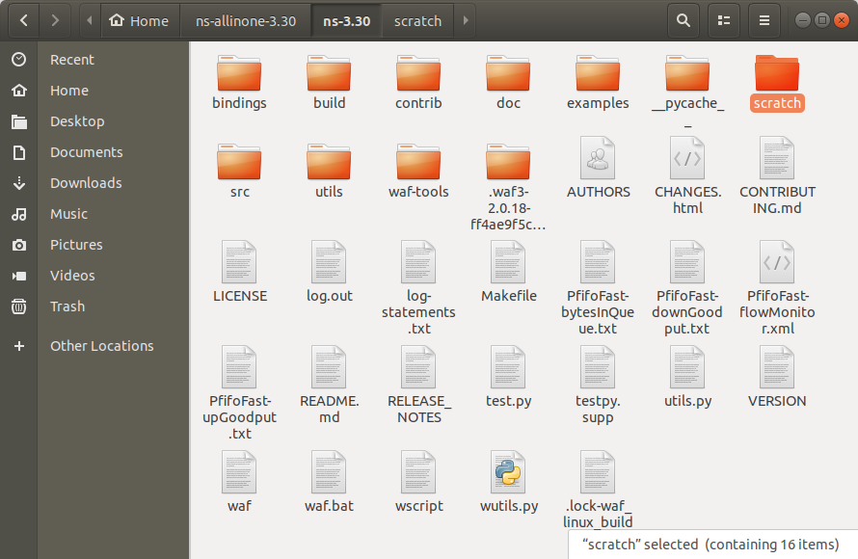

In the scratch file I would have to put the queue-discs-benchmark file.

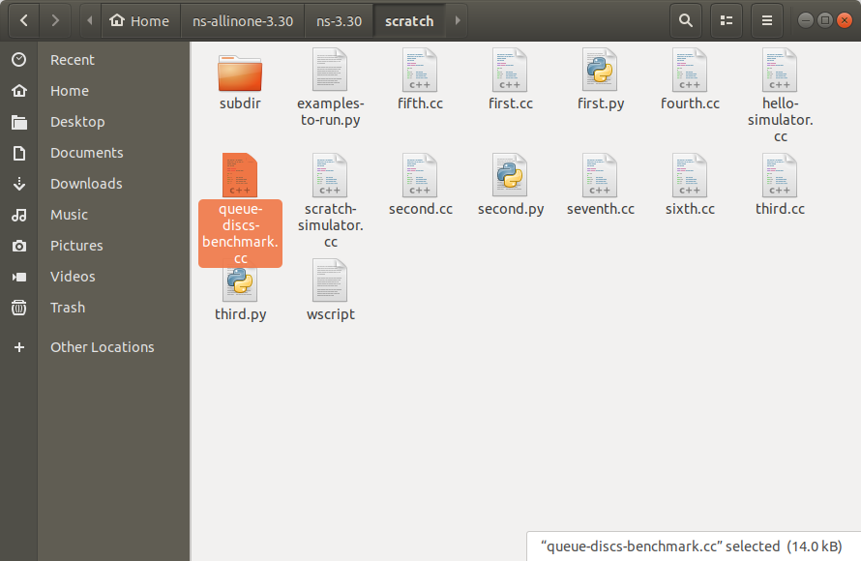

Just like this, one more folder should be chosen to keep the mentioned file. For this, I might select the build file from ns-3.30.The build file is also containing a scratch file where the files should be put in.

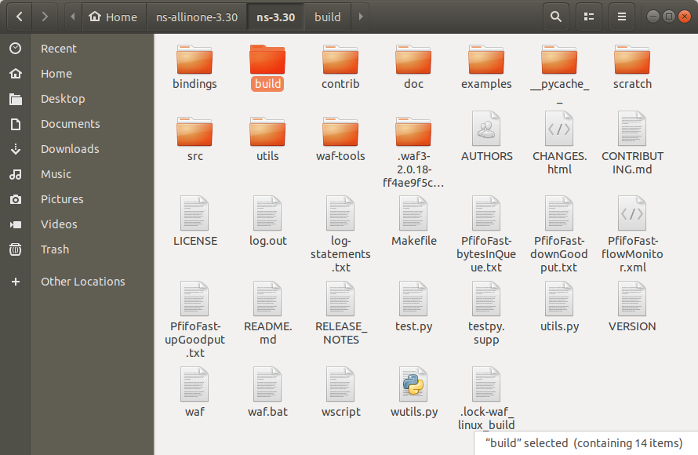

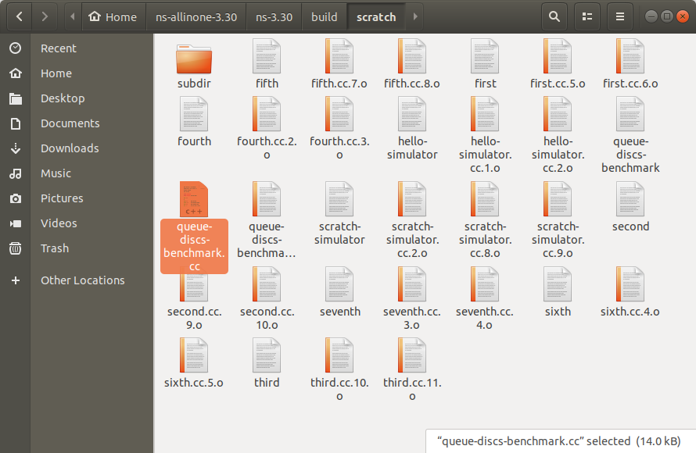

After done with this step I need to open the terminal(alt+ctrl+t) & write the following commands-

cd

cd ns-allinone-3.30/ns-3.30

./waf –run scratch/queue-discs-benchmark

**Output:** After writing the following commands the evaluation provides the output

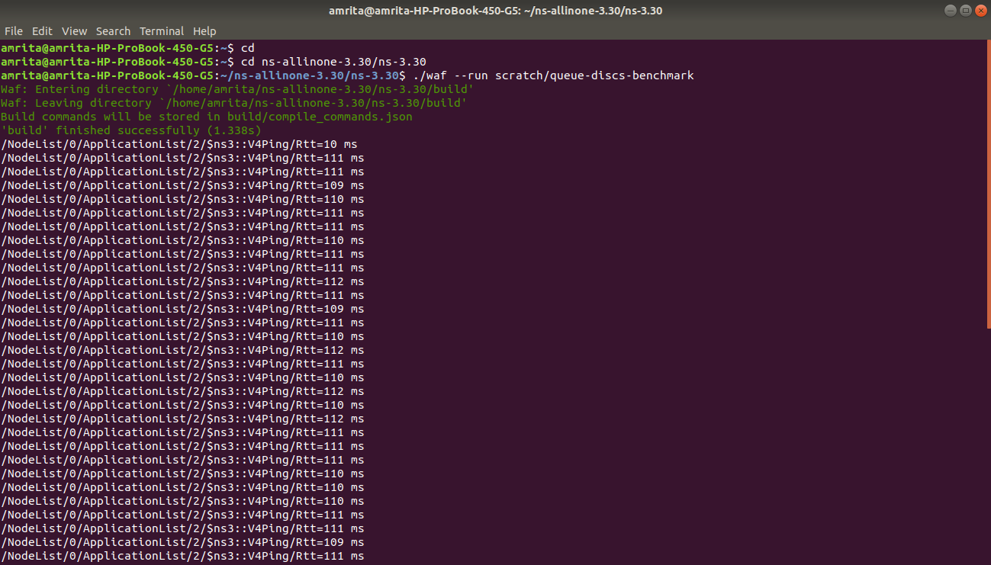

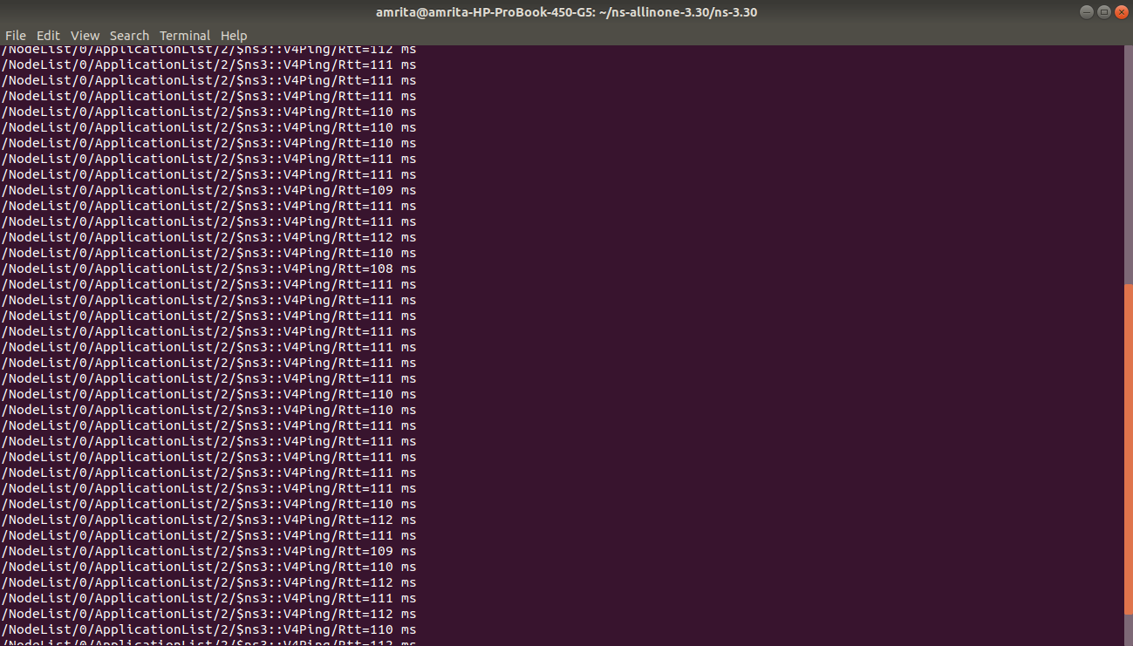

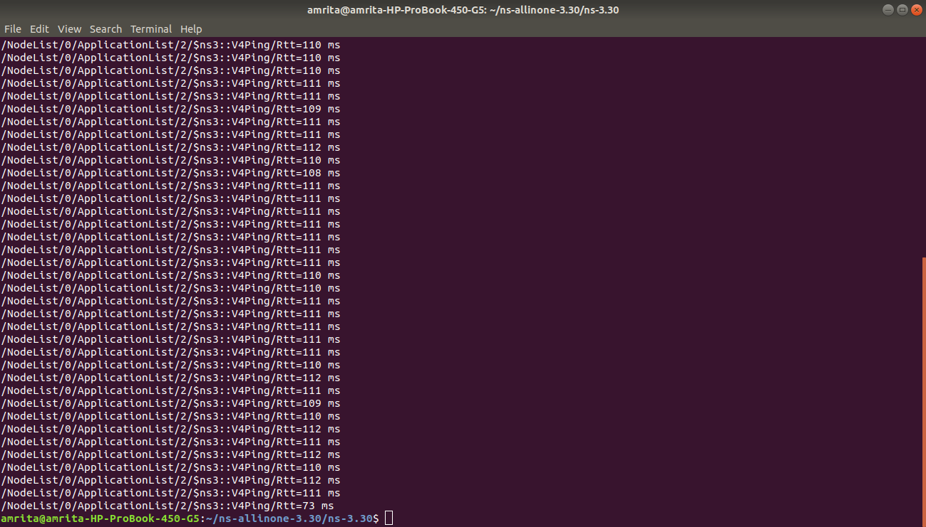

**Conclusion:** In this lab, both the TCP and router queues have been done with some steps. The queues connection make the network topology. Those topology consisted of different nodes with same number of queue sizes. Also including the measurement in each plots of the graphs throughput/time, cwnd/time and packet loss/time for each of the flows. One of the important purposes is to prevent the TCP and routing issues specially the loops. Because of having the manner for selecting the significant routes.